# 1. List of all necessary clean facility utilities

The biopharmaceutical manufacturing uses a multitude various, precise processes that require different resources and energies, for example water, electricity, and compressed air. These can be classified into “Clean Utilities and Technical Utilities (also called Black Utilities)” categories (see Table XX).[1]

|  |  |
| --- | --- |
| **Clean Utilities** | **Technical Utilities (Black Utilities)** |
| Water for Injection (WFI) | Wastewater Collection/ Inactivation (Bio / non-Bio) |
| Purified Water (PW) | Water (Portable, Cooling, Heating and Fire Water) |
| Clean Steam | Compressed Air |
| Clean Compressed air | HVAC |
| Process Air | Electrical Power |
| Process Gases (N2, O2, CO2) | Technical Steam (Black Steam – Fresh / Used) |
|  | Waste (Plastics / Paper / Other) |
|  | Gasoline |
|  | Nitrogen Liquid |

## 1.1 Clean Utilities

Clean utilities have a direct impact on the quality of the product; therefore, they are defined as the necessary requirements by the production process. The cleanliness of the utilities must be as pure as possible to make sure that no novel contaminant is introduced into the production process. Clean utilities comprise:[2]

|  |  |
| --- | --- |
| **Clean Utilities** | **Utilized for** |
| WFI and PW | * To produce buffers and cell culture media * For CIP operations |
| Clean Steam | * For sterilization of product contacting surface |
| Clean Compressed Air | * For blow down of transfer pipes and drying of product contacting surface after cleaning and sterilizing * Pneumatic valves within the transfer pipe network and unit operations |
| Clean Process Gases | * Within the cell culture processes |

## 1.2 Technical Utilities

Technical utilities, also known as black utilities, are used for the direct support of the process operation, while it does not have a direct contact with the product. Technical utilities may comprise:[3]

|  |  |
| --- | --- |
| **Technical Utilities** | **Utilized for** |
| Potable water | * To higher grades of water * To use within the domestic systems of a facility |
| Fire Water | * For the safety |
| Cooling/chilled water/glycol | * For non-product contact cooling applications |
| Hot water/technical steam | * Required for non-product contact heating applications |
| Electrical power | - |
| Natural or liquefied gas | * Needed for firing gas boilers |
| Wastewater collection/inactivation | - |

## 1.3 Clean Water and Steam

The biopharmaceutical manufacturing uses water, which needs to be suitable for the process steps. This generally means it must be as clean as necessary in regard to bioburden, particles and soluble. The kind of clean water which is necessary for each step is determined by the process step. The purity is measured by conductivity, pH, total organic carbon, and endotoxin content. The designer must consider the different grades of water production depending to the United States Pharmacopeia (USP), WHO, or European Pharmacopoeia (EUPH) or other region-specific guidelines which are portable water, purified water (PW) and water for injection (WFI). Each kind of water is “cleaner” as the type before.[4]

Portable water is basically tab water while PW and WFI are generated in a cascade in a continuous manner. The process is guided under GMP and starts with drinkable water of the local provider, also defined, or described as potable water. The potable water is filtered by Nanofiltration and followed by UV sterilization. Then it will be transferred to the reverse osmosis system. Reverse osmosis is used to produce WFI. In order to have a continuous flow even if filters have to be exchanged 2 reverse osmosis system are installed as well as 2 nanofiltration systems . The PW can be used for USP, DSP, MP and BP. Clean steam is also generated from PW via distillation and is predominantly used for cleaning. For the WFI generation, the PW goes through a multi-distillation column which saves energy. WFI is also used in USP, DSP, MP and BP. (see Schema) [5]

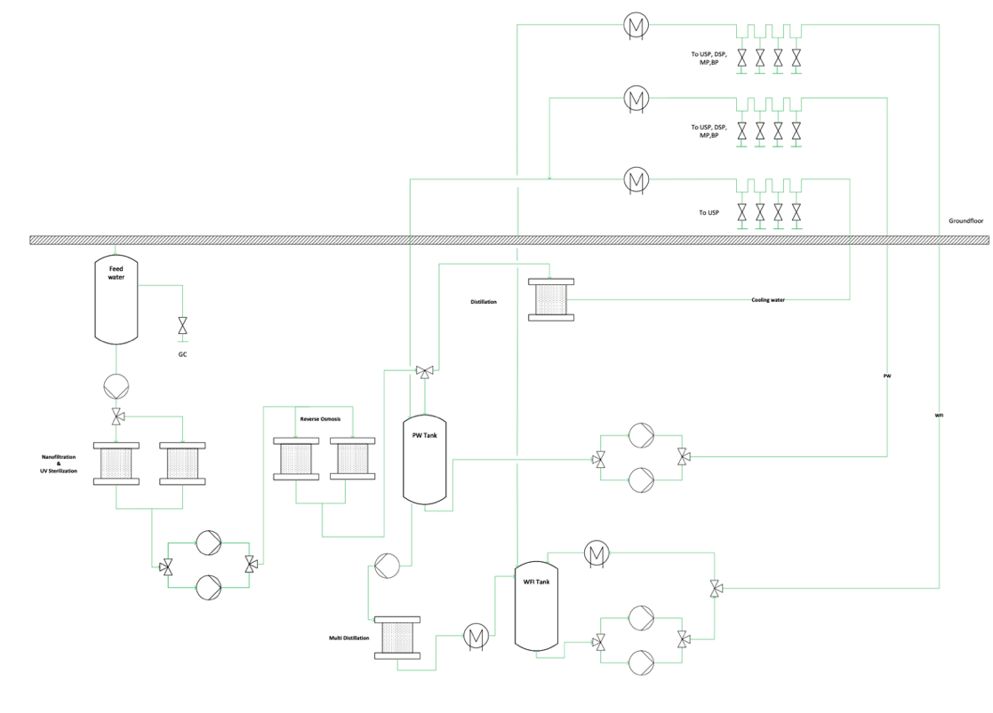

Zoom

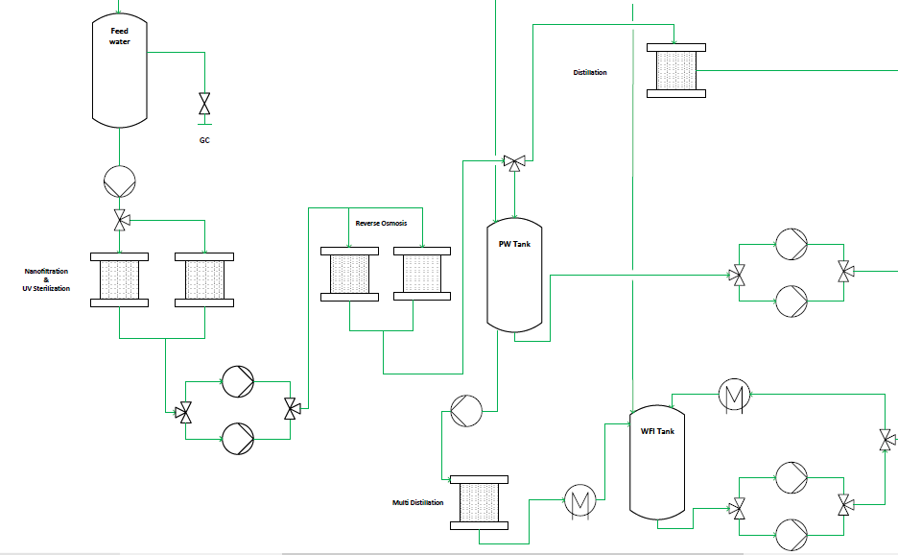

Characteristics of the System:

Dead legs need to minimized to avoid stagnant water (bioburden), material = Stainless Steel 316L, constant turbulent flow needs to be achieved through the pumps to reduce bacterial growth, a positive pressure between the loop and Points of use (POUs) needs to be guaranteed to avoid contamination, adequate slope of piping toward the drains needs to be achieved to allow complete drainage, air breaks to wastewater need to be installed to eliminate backwash, two pumps are used for redundancy.

There are two types of steams which are required within the biopharmaceutical facility:[6]

|  |  |  |
| --- | --- | --- |
| **Kind of steam** | **Production** | **Used for** |
| Technical or  black steam | Produced from a boiler | Heating of non-product contacting surfaces and systems |
| Clean steam | Generated from treated water free of volatile additives | Thermal disinfection or sterilization processes  For sterilization of products, and more typically equipment |

A steam produced by the boiler is pressurized and used to produce the clean steam of the clean steam distillation column.

## 1.4 Process Gases

Product gases have an impact as an effect of product quality.

The utilized process gases are:[7]

|  |  |
| --- | --- |
| **Process Gas** | **Used For** |
| Nitrogen (N2) | * Inert gas for the conditioning of products in storage and transportation * During the manufacture of bulk drug substances * The production of finished goods |
| Oxygen (O2) | * Cultivation of cells within a bioreactor or fermenter |
| Argon (Ar) | * During the manufacture of bulk drug substances * The production of finished goods |
| Carbon dioxide (CO2) | * Cultivation of cells within a bioreactor or fermenter * In incubator systems used for initial cell growth * During the manufacture of bulk drug substances * The production of finished goods |
| Compressed air (CA) | * Cultivation of cells within a bioreactor or fermenter * Throughout the production facility within pneumatic systems |

## 1.5 Waste Treatment

During biopharmaceutical processes waste is always generated. The majority of the waste is from the production process steps and can be classified in biological waste and non-biological waste. For instance, the kind of waste in an upstream process can be generated during the cell growth media, bioreactor, media culture hold bags, filters, and tubing or during the steam in place process a steam waste can be generated. Waste can be differentiated to solids, liquids, and gases. The kind of waste is summarized in the following table with their impact.[8]

|  |  |
| --- | --- |
| **Non-Bioactive Waste** | * Directly discarded or slightly treated to diminish the environmental impact |
| **Liquids** | * Non-biological liquids waste * Collection within a waste tank followed by chemical treatments * Harmful waste   + Further purification processing ma required |
| **Solids** | * Biologically exposed solid waste   + Sanitized either via an autoclave or chemically * Non-active solid waste   + Can be double-bagged and taken out of the facility to landfill or incineration sites, depending on local practices * Like non-biological liquid waste: some deactivation may require by some means prior to exiting the facility. |
| **Exhausted Air** | * Non-hazardous exhausted air   + From vent filters not hazardous to health or environment * Odorous or solvent vapors   + Deodorization or organic solvent emission reduction |
| **Hazardous Waste Decontamination** | * Can be solid and liquid waste * Decontamination systems   + Must ensure inactivation of all microorganisms, including survival structures   + Processes must be validated by microbial challenge testing |

## 1.6 HVAC

The HVAC system should provide for the worker a well-appointed working environment as well as the provider of rooms and the manufacturing process with the required grade of cleanliness and pressurization to ease cGMP and BSL requirements for manufacturing. The basic four HVAC system functions are:[9]

|  |  |
| --- | --- |
| **Maintain room cleanliness** | * Control of airborne particles, dust, and micro-organisms   + Performed through air filtration using high-efficiency particulate air (HEPA) filters |
| **Maintain room pressure** | * Air flow must come from the cleaner area toward the adjoining space   + To reduce the chance of airborne contamination   + Achieved by more air into the cleaner space than is mechanically removed from that same space |
| **Maintain space moisture** | * Controlled by cooling air to dew point temperatures or by using desiccant humidifiers   + Can affect the efficacy and stability of drugs |
| **Maintain space temperature** | * Can affect production   + Directly by impacting chemical or biochemical reactions   + Indirectly by fostering growth of microbial contaminants in the process or on workers |

# 2. List all equipment used for clean utilities

A list of the main equipment used for clean utilities is provided. This table is intended to show a simplified summary of all the necessary equipment lists for clean utilities. The major components in a clean utility are shown, followed by where they can be found (stages). Then all equipment necessary for production / generation is listed.[10]

|  |  |  |  |  |  |  |
| --- | --- | --- | --- | --- | --- | --- |
| **PW** | **WFI** | **Clean Steam** | **Clean Compressed air** | **Process Air** | **Process Gases** | **Liquid Nitrogen** |
| ***Basement*** | ***Basement*** | ***Basement*** | ***Basement*** | ***2nd Floor*** | ***Outside*** | ***Outside*** |
| Heat exchanger | Heat exchanger | Distillation Column | Filters | Filters | Storage Tanks for all gases | Storage Tank |
| Storage Tank | Storage Tank | Compressor | Pneumatic Valve | Cooler | Pneumatic Valve | Pneumatic Valve |
| Reverse Osmosis | Distillation Column |  | Storage | Heater + Reheaters |  |  |
| Nano Filtration |  |  | Compressor | Humidifier |  |  |
| Water Treatment |  |  |  | Mixing Chambers |  |  |

## 2.1 Requirement

In this table the amount of the clean utilities which is required for USP and DSP is shown. These numbers have been estimated from the numbers given by the DSP, USP block flow diagrams and the URS.

|  |  |  |  |  |  |
| --- | --- | --- | --- | --- | --- |
|  | **WFI\*** | **PW\*** | **Solid Waste\*** | **Liquid Waste\*** | **Liquid Biological\*\*** |
| DSP | 3541 | - | 625 | 42000 | - |
| USP | - | 2500 | - | - | 2500 |

* Volume per batch [L]

** Waste per batch [L]

# 3. Zone concept: Basement

The zone concept of the basement is shown below in figure xx. In here, the rooms corresponding to clean and technical utilities can be found. Both the room design and selection of equipment were performed in HakoBio’s platform. Due to lack of availability of the actual equipment described in the previous section, the equipment portrayed was selected as an alternative. The electricity room was left empty for the previously mentioned reason.

Figure xx: room concept: basement. Designed with HakoBio.

# 4. Points of use zone concept

## 3.2 Points of use

The points of use are shown in the figure below. The first step to design the points of use zone concept, was to determine which utilities were required for the different processes and their respective rooms. For the clean utilities, rooms such as media preparation, buffer preparation & storage, Inoculum, USP production, USP harvest and DSP V+ have points of use for both Water For Injection (WFI) and Potable Water (PW). For the quality room, only PW has been supplied. Points of use for Clean compressed air are present in the USP production and USP harvest for cell cultivation and fermentation processes. This clean utility is also present in buffer preparation & storage, and DSP V+, with the last one requiring two points of use. For the process air, a point of use in the USP production room was included. In addition to this, a supply for process gases (N2, O2, CO2) are present in the USP production, USP harvest and inoculum rooms. A single point of use for clean steam is set in buffer preparation & storage. The technical facilities such as biological, liquid, and solid waste are distributed across the main rooms of buffer and media preparation, USP and DSP. Since biological active waste must be inactivated prior to disposal, a waste management room was design to carry out the inactivation.

Figure xx: HVAC and points of use zone concept

Table xx: Points of use of clean and technical utilities per process

1. Reference Moodle: Facility Design and Process Utilities
2. Reference Moodle: Facility Design and Process Utilities
3. Reference Moodle: Facility Design and Process Utilities
4. Reference Moodle: Facility Design and Process Utilities
5. Reference Moodle: Facility Design and Process Utilities
6. Reference Moodle: Facility Design and Process Utilities
7. Reference Moodle: Facility Design and Process Utilities
8. Reference Moodle: Facility Design and Process Utilities
9. Reference Moodle: Facility Design and Process Utilities
10. Reference Moodle: Facility Design and Process Utilities